Simple slab rescue
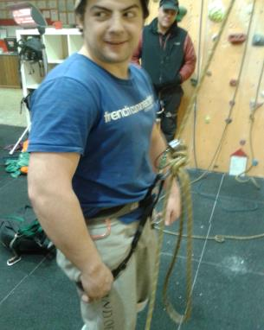
Tie off belay plate on novice belayer.
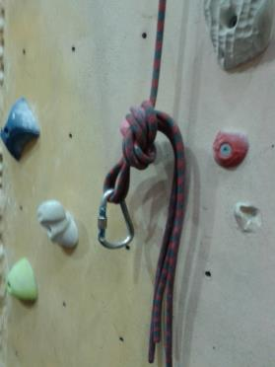
Create double overhand knot with both ends of the rope on the line next to them and attach crab

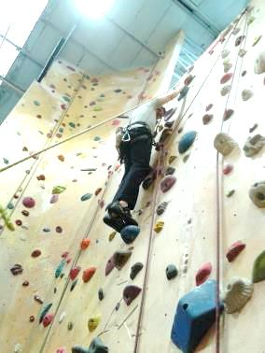
Send up knot to stuck climber and persuade them to attach crab to belay or rope loop. Tell them its for extra safety. Gently assist them to lean backwards. Untie belay plate and lower to ground. Remember you are not dragging them off the wall and just want to get them out of the situation as quickly as possible and back down to you. They may not be very happy with you but at least they won’t be stuck up the wall and scared.
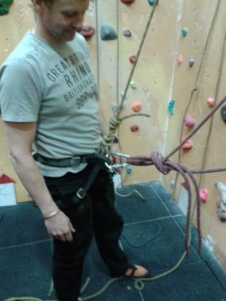
Crab can be attached to belay loop or rope loop

